Circuit with Piezo alarm, PIR sensor

And Temperature Sensor

CIRCUIT DIAGRAM:

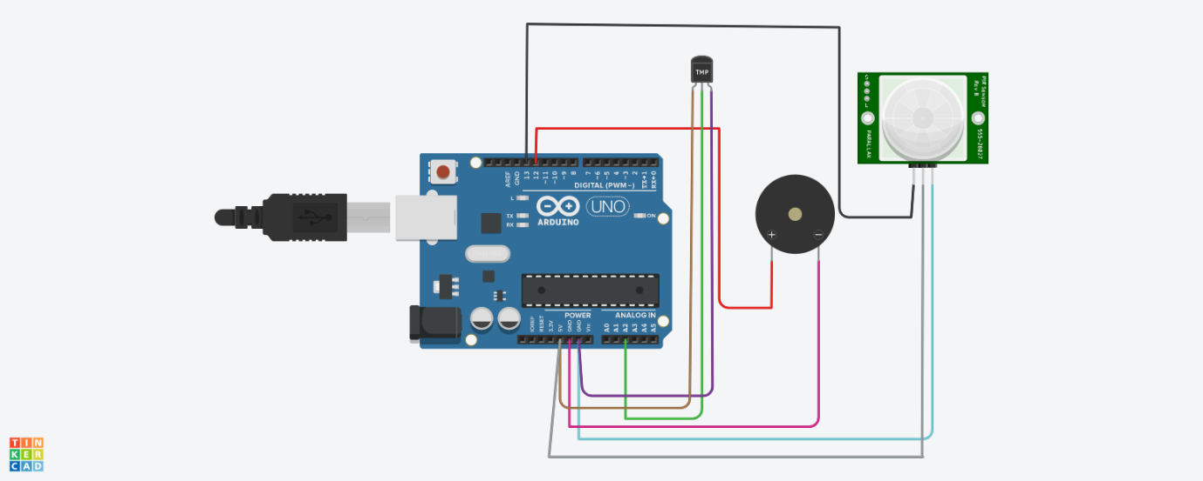

CODE:

void setup()

{

Serial.begin(9600);

pinMode(13,INPUT);

pinMode(12,OUTPUT);

}

void loop()

{

double data=analogRead(A2);

double n=data/1024;

double volt=n*5;

double off=volt-0.5;

double temperature=off*100;

int motion=digitalRead(13);

for(int freq=5;freq<=6;freq++)

{

if(temperature>=60)

{

Serial.println("Temperature is above 60");

tone(12,freq);

delay(100);

}

else

{

Serial.println("Temperature is below 60");

noTone(12);

}

}

for(int freq=7;freq<=8;freq++)

{

if(motion==1)

{

Serial.println("Motion Detected");

tone(12,freq);

delay(200);

}

else

{

Serial.println(" No Motion");

noTone(12);

}

}

}

OUTPUT:

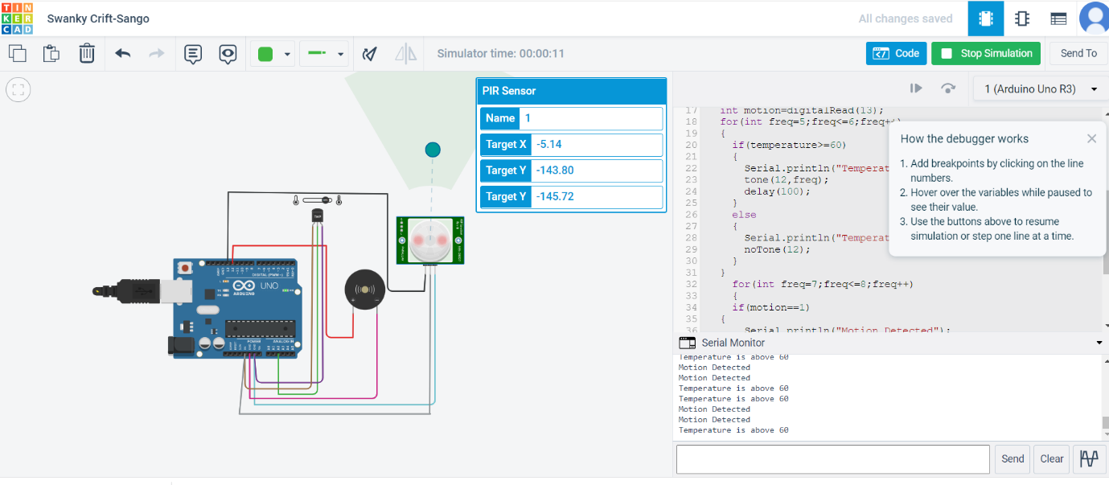

VIDEO LINK:

https://drive.google.com/file/d/1mZLFSyipWNrH2IWOskY-hWK1E_Rl720R/view?usp=sharing